
The University Of Azad Jammu &
Kashmir,Muzaffarabad
Name: Hassan Gillani
Roll NO: 2024-SE-42
Course Code:CS-2203
Submission Date:9thMarch,2026
Course Title:Computer Networks
Instructor Name: Engr. Asma Javaid
Department Of Software Engineering
LAB TASK 2 - Create and Test a Simple LAN in Cisco Packet Tracer

Objective
The objective of this lab is to create a simple Local Area Network (LAN) using Cisco Packet Tracer and test connectivity between two PCs using basic CLI commands.

➢ Part 1 – Network Topology Creation
Step 1: Open Cisco Packet Tracer
First, I opened the Cisco Packet Tracer application.
Step 2: Add Devices
Then I added the following devices to the workspace:
- 1 Switch
- 2 PCs (PC0 and PC1)
Step 3: Connect the Devices
After adding devices, I connected them using Copper Straight-Through cables.
Connections:
- PC0 → Switch
- PC1 → Switch
Now both PCs are connected to the same switch forming a simple LAN network.
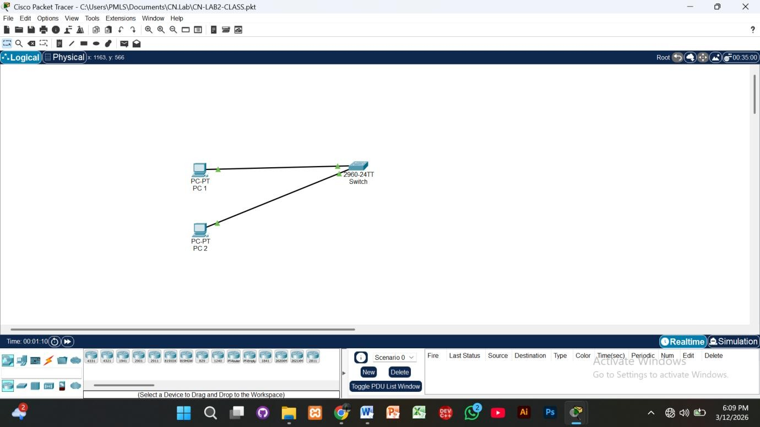

➢ Part B – IP Address Configuration
After creating the topology, I manually configured the IP addresses for both PCs.
PC0 Configuration
- IP Address: 192.168.1.1
- Subnet Mask: 255.255.255.0
PC1 Configuration
- IP Address: 192.168.1.2
- Subnet Mask: 255.255.255.0
Note:
No default gateway was configured because the network uses only a switch and routing is not required.
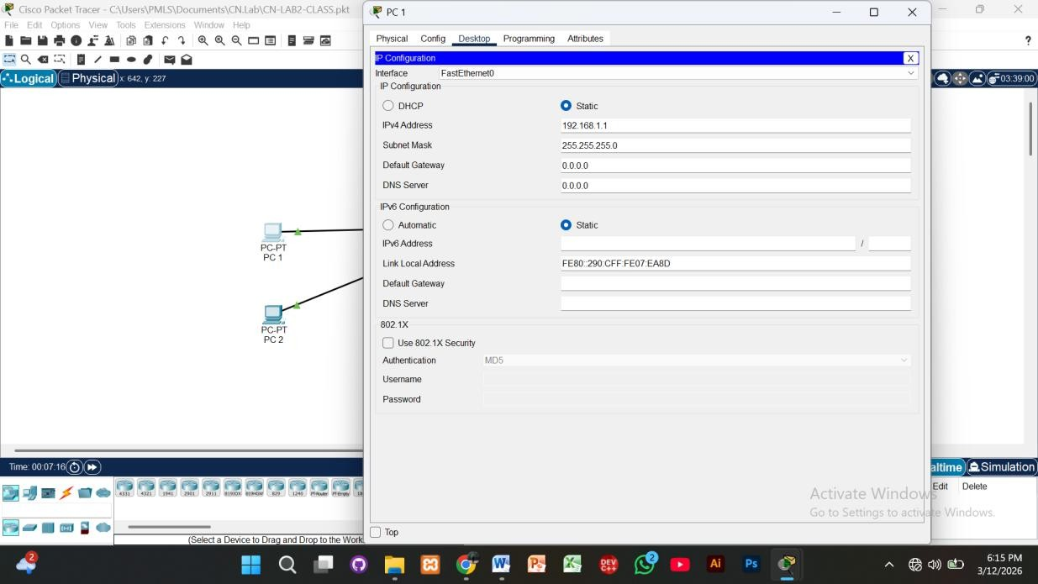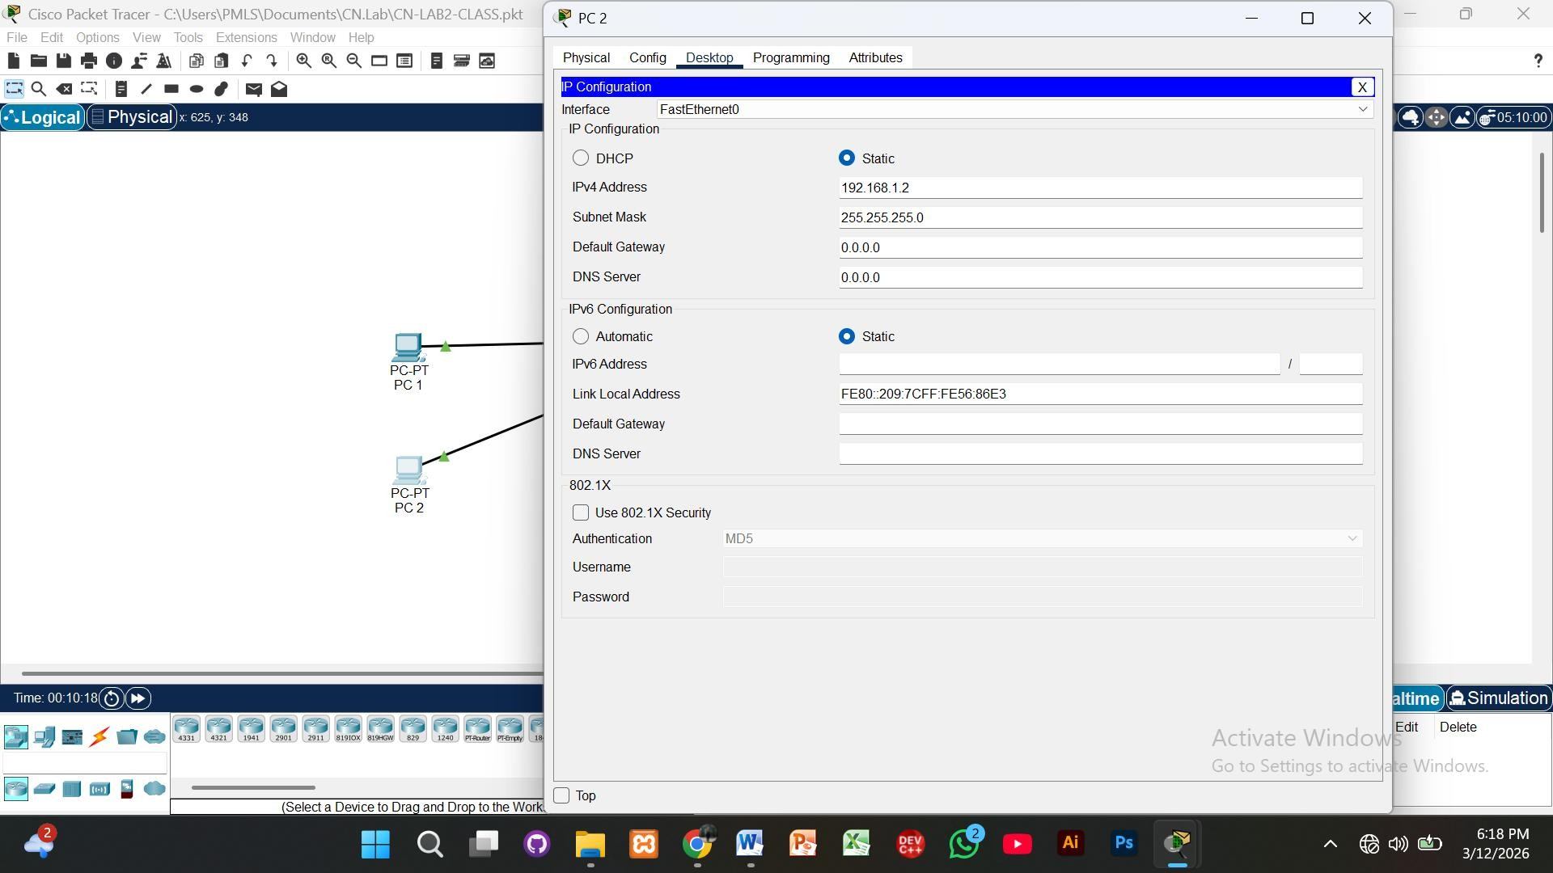

➢ Part C – Network Testing Using CLI Commands
To test the network connectivity, I opened the Command Prompt (CLI) of the PCs and executed different commands.
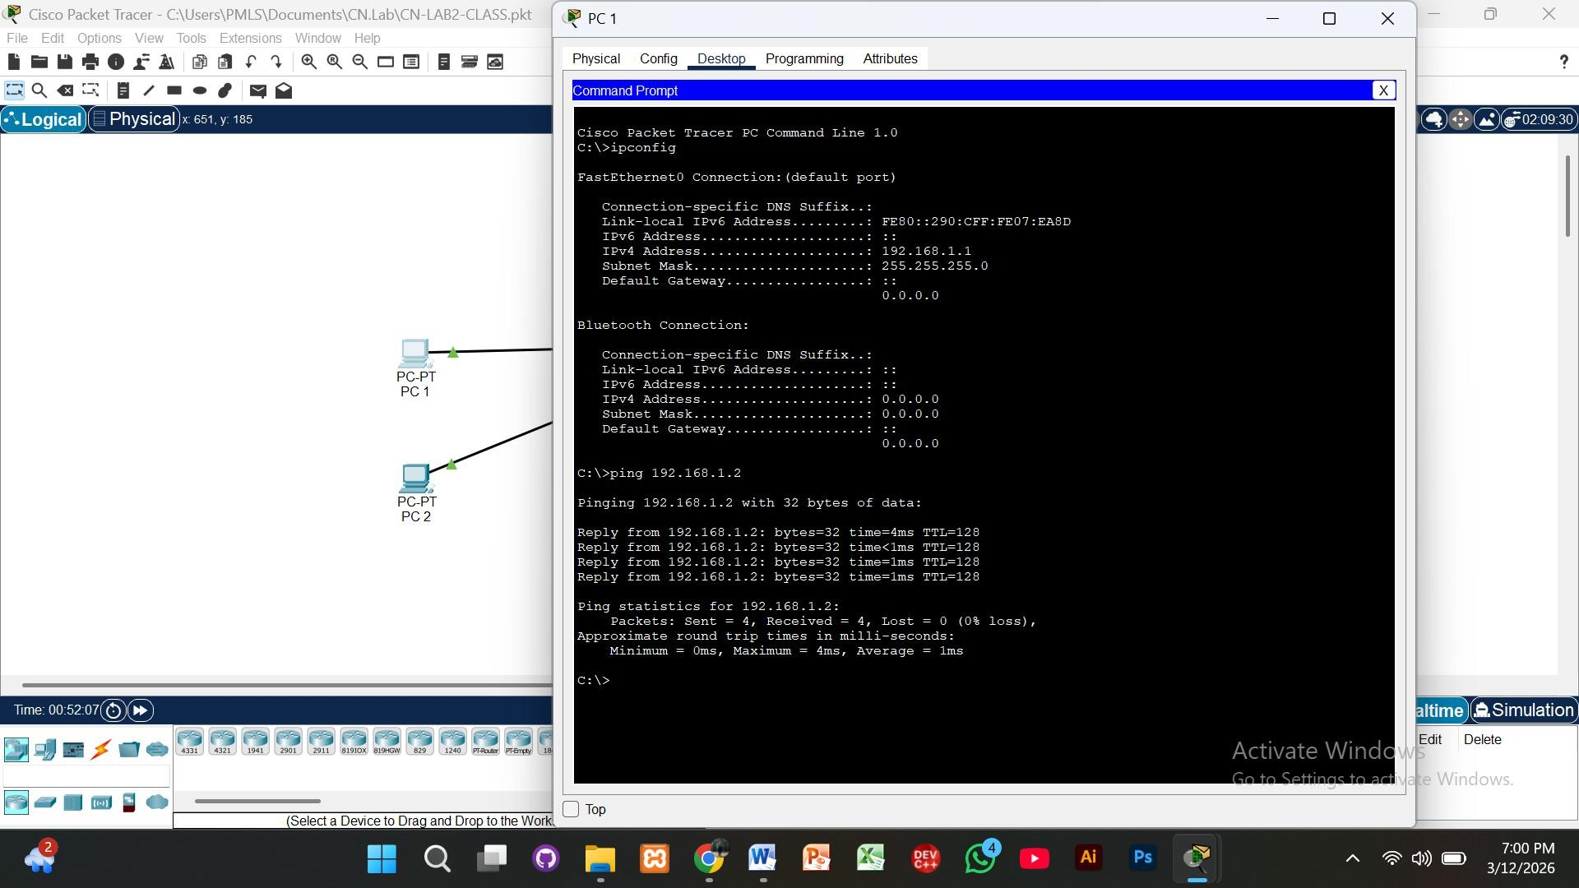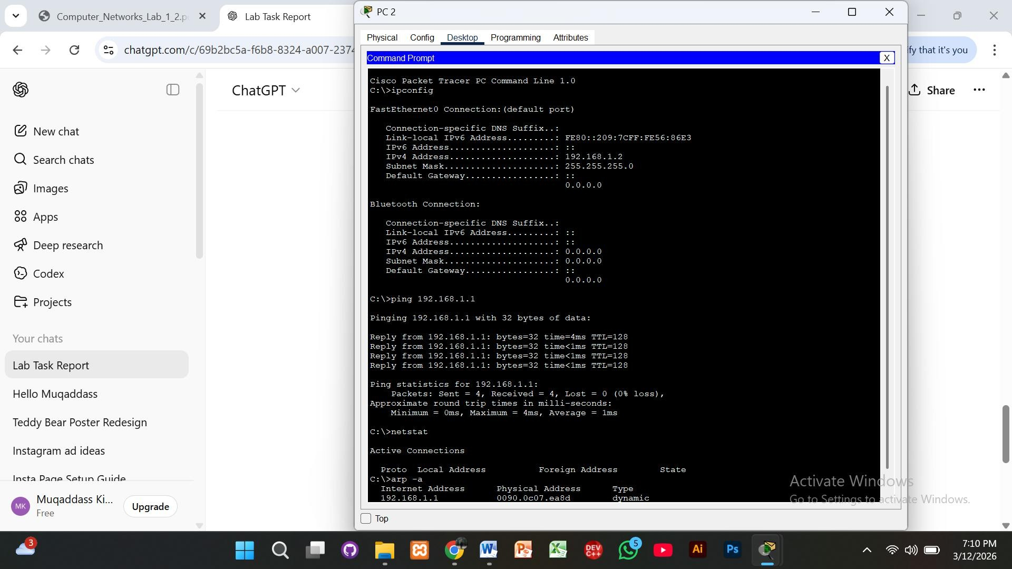

➢ Conclusion
In this lab, I successfully created a simple LAN network using Cisco Packet Tracer. Two PCs were connected to a switch and assigned IP addresses manually. Using CLI commands such as ipconfig, ping, tracert, arp -a, and netstat, I verified that both PCs can communicate successfully within the network.

